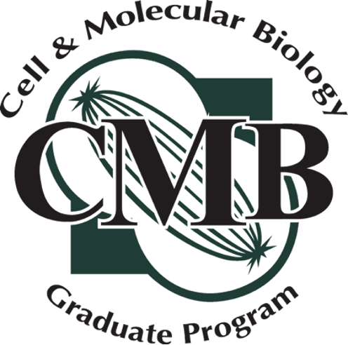

Annual Progress & Committee Report for Ph.D. Students

Instructions:
- This document is the official Guidance Committee review of your coursework and research progress, documenting committee agreement (or rarely, disagreement).
- Part 1 is due to your committee one week before each committee meeting. Parts 2 and 3 should be pre-filled for the meeting and submitted to your CMB Representative. Parts 1-3 may be reused and updated for subsequent committee meetings.
- At each meeting, be prepared to review CMB requirements (completed and pending), accomplishments, and goals (summarizing Parts 1-3).
- After each meeting, your CMB representative will draft of Part 4.
- The draft will be circulated to your committee members for edits and signatures.
- The report will then be sent to you for signature. Any discrepancies must be reported promptly to your CMB Representtative, Advisor, and, if needed, the CMB Director.
- The fully signed report must be submitted
- The final report, signed by all, must be forwarded to the CMB Director and Graduate Program Coordinator within two weeks of the meeting.

Student’s Name

Today’s Date

Date of previous Guidance Committee meeting

Semester/year of entry into BMS Semester/year of entry into CMB

Adviser

Overall GPA

Date of Comprehensive or Anticipated Date of Exam
Anticipated date of comprehensive exam should be no later than Fall semester of Year 3 after joining BMS. For example, if the student joined BMS in Fall 2024, the comprehensive exam should be completed by Fall 2026.

Are you requesting permission to write today? Yes No
Permission to write is granted by agreement of the student, adviser, and committee when all agree that the student will be ready to defend the completed dissertation within 6 months of the committee date.

PART 1. STUDENT RESEARCH PROGRESS REPORT
Please attach the following information, answering questions 1-6, using subheadings provided for each question. 2-page limit. Distribute to the Guidance Committee, CMB Office (CNS.CMB@msu.edu), and Program Director at least one week prior to each committee meeting, including the first committee meeting.

- Abstract: Summarize your research, 300 words or less.
- Long-term goals: What are your long-term professional goals? Where to you see yourself in 10 years?
- Accomplishments: Describe your major research accomplishments in the past year.
- Short-term goals: What are your research goals for the upcoming year?
- Obstacles: What difficulties or obstacles have you encountered that have hindered your research progress?
- Student impression: Are you satisfied with your research progress? Do you think that you are on track towards completion of your degree within about 6 years from the start of your Ph.D.?
- Student needs: What can the CMB program, Research Adviser, and/or Guidance Committee do to help you accomplish your goals and overcome obstacles?

PART 2. PUBLICATIONS AND ACTIVITIES
Publications and papers submitted. Include complete citation or stage of submission (in review or in revision, date of submission).

Presentations. Indicate the conference name, location, date, title of presentation, and whether Oral, Poster, or other format. All formal scientific presentations should be listed, whether at a professional conference or for local programs (eg, CMB Research forum).

List Lay publications. Include complete citation.

List Service activities. Include service such as participation in CMB or BMS/GRIT activities, your home department, University-wide service, and national/international service. Include both outreach and professional service. Provide a 1-sentence description of the activity (optional).

Honors/Awards/Fellowships. Include details such as dates, locations, award names.

Fellowship applications submitted. Include all submissions, even if not funded. Indicate whether the application is in review/pending, and whether it will be funded, if known. You may provide priority score, if applicable.

(Optional) Do you have any feedback to the Director about the CMB Program?

PART 3. In the table below, please list all courses taken.
This section can be reused and updated for each committee meeting. Please distribute this to the Guidance Committee one week prior to the committee meeting along with the Student Progress Report.

Course number Course Title Semester Grade

BMB 801 Molecular Biology

BMB 825 Cell Structure & Function

Check all that apply; at least one is required:
BMB 833 Prokaryotic Molecular Genetics

BMB 835 Eukaryotic Molecular Genetics

BMB 856 Plant Molecular and Omic Biology

Indicate semesters in which CMB 892 were taken; at least two are required:

CMB 892 Research Forum

CMB 892 Research Forum

List Electives; at least two are required:

List Seminars; at least three are required:

List Teaching assignments; at least one is required:

PART 4. GUIDANCE COMMITTEE REPORT.
This section is to be filled out by the CMB Representative of the Guidance Committee. After obtaining signatures from each member of the Committee, the Adviser, and the student, this form is to be returned by the student to the CMB Office(CNS.CMB@msu.edu) within 14 days of the Committee meeting.

- Did the student submit a progress report 1 week prior to the meeting?

Yes Yes, but less than 1 week before the meeting

No

- The student has made acceptable progress since the last committee meeting (or since joining their adviser’s lab if first committee meeting):

Agree 1 2 3 4 5 Disagree

Comments:

- The conclusions drawn from the research are supported by the data.

Agree 1 2 3 4 5 Disagree

Not applicable; this is the student’s first committee meeting, or no data were presented.

Comments:

- Sound scientific rationale and/or preliminary data justifies the proposed research plan for the upcoming year.

Agree 1 2 3 4 5 Disagree

Comments:

- The research presented is in a state suitable for publication.

Agree 1 2 3 4 5 Disagree

Comments:

- The student is finished/near finished with the research for the dissertation and should begin writing the thesis.

Agree 1 2 3 4 5 Disagree

Comments:

- Briefly state the research aims that have been accomplished since the previous committee meeting:

- Briefly state the research plan/areas of investigation for the upcoming year:

- Briefly discuss the student’s milestones for towards completion of the degree:

- Briefly discuss career development activities suggested for the student, such as writing or presentations classes/workshops, grant writing activities, postdoctoral or job application processes, etc.

Signatures:

Adviser Date

Committee Member Date

Committee Member Date

Committee Member Date

Committee Member Date

Committee Member Date

Student Date

