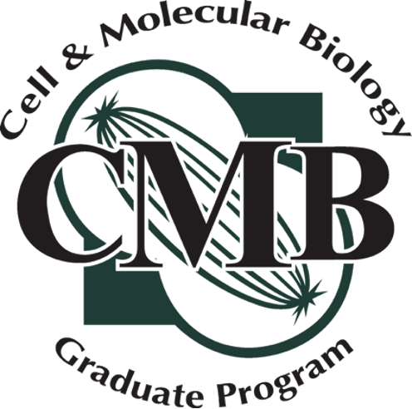

ANNUAL PROGRESS & COMMITTEE REPORT FOR PH.D. STUDENTS

Student’s Name Today’s Date

Date of last meeting (or check if first) Adviser

Semester & year of entry into BMS Semester/year of entry into CMB

Current GPA Date/Anticipated date of Comprehensive

Are you requesting permission to write today? Yes No
Permission to write is granted by agreement of the student, adviser, and committee when all agree that the student will be ready to defend the completed dissertation within 6 months of the committee date.

PART 1. STUDENT RESEARCH PROGRESS REPORT
On a separate page, address items 1-8, 2-page limit. Submit to your Advisory Committee one week before each committee meeting.

- Abstract: Summarize your research, including your specific aims (300 words or less).
- Progress on each aim: summarize progress on each aim, noting any changes in direction since your last meeting
- Accomplishments: Describe or list your main research accomplishments in the past year
- Short-term goals: Describe or list your research goals for the upcoming year.
- Long-term goals: Describe or list your long-term professional goals.
- Obstacles: Describe or list any difficulties or obstacles have you encountered that have hindered your research progress.
- Student impression: Are you satisfied with your research progress? Do you think that you are on track towards completion of your degree?
- Student needs: What can the CMB program, Research Adviser, and/or Advisory Committee do to help you accomplish your goals and overcome obstacles?

PART 2. PUBLICATIONS AND ACTIVITIES

For each item, provide full citations, dates, and stages of publication, submission, or award. Ensure that each of these lists are maintained cumulatively throughout the course of your PhD.

- Publications and submitted manuscripts.

- Presentations at professional conferences. Indicate format of presentation (Oral, Poster, etc.)

- Lay publications.

- Service activities. Include both outreach and professional service.

- Honors/Awards. Include a short description.

- Fellowship applications submitted/funded. Include all submissions, even if not funded.

- List any other accomplishments you would like to mention.

PART 3. COURSEWORK

This section should be reused and updated for each committee meeting. If you have filled out a previous version of this form, you may substitute this for the prior version.

Course Number | Course Title | Semester | Grade
BMB 801 | Molecular Biology
BMB 825 | Cell Structure & Function
Check all that apply; at least one is required.
MMG 833 | Prokaryotic Molecular Genetics
BMB 835 | Eukaryotic Molecular Genetics
BMB856 | Plant Molecular and ‘Omic Biology
Indicate semesters in which CMB 892 were taken; at least two are required.
CMB 892 | CMB Research Forum
CMB 892 | CMB Research Forum
List Electives; at least two are required.
List Seminars, which are usually 1 or 2 credits. Three seminars are required, and at least two must be based on reading, interpreting, and presenting scientific papers.
Indicate whether you have taken or plan to take the CMB Grant Writing Course. This course does not count as one of the Seminar requirements
CMB 800 | Grant Writing Skills for Cell & Molecular Biology
List teaching assignments, if applicable
 |  |  | n/a
 |  |  | n/a
 |  |  | n/a

PART 4. GUIDANCE COMMITTEE REPORT

This section is to be filled out by the CMB Representative of the Guidance Committee. After obtaining signatures from each member of the Committee, the Adviser, and the student, this form is to be returned by the student to the CMB Office (CNS.CMB@msu.edu) within 14 days of the Committee meeting.

For the first 5 questions, circle one number, with 1 equivalent to “strongly agree” and 5 equivalent to ‘strongly disagree’. Comment as appropriate.

- The student has made acceptable progress since the last committee meeting.

Agree 1 2 3 4 5 Disagree

Not applicable; this is the student’s first committee meeting, or no data were presented.

Comments:

- The conclusions drawn from the research are supported by the data.

Agree 1 2 3 4 5 Disagree

Not applicable; this is the student’s first committee meeting, or no data were presented.

Comments:

- Sound scientific rationale and/or preliminary data justifies the proposed research plan for the upcoming year.

Agree 1 2 3 4 5 Disagree

Comments:

- The research presented is in a state suitable for publication.

Agree 1 2 3 4 5 Disagree

Comments:

- The student is ready for their comprehensive exam or should plan to take their comprehensive exam the next 6 months. Please provide additional details comments below as needed

Agree 1 2 3 4 5 Disagree

N/A – the student has already passed their comprehensive exam.

Comments:

- The student is finished/near finished with the research for the dissertation and should begin writing the thesis.

Agree 1 2 3 4 5 Disagree

Comments:

- Did the student submit a progress report 1 week prior to the meeting?
(Check one box)

Yes No Yes, but less than 1 week before the meeting

- Indicate in the table below the student’s strengths and areas needing improvements by indicating a number within each category:

 | 1  Very strong | 2  Strong | 3  Equal areas of | 3  Needs some improvement | 5  Needs much improvement | U  Unable to evaluate
Knowledge of the scientific field of study
Presentation skills

Writing skills

- Overall, the student’s progress is satisfactory for their stage of the PhD program:
(Circle one)

Yes No

- Does the student have an adequate research plan for the upcoming year? Discuss briefly.

- Were career plans or development activities suggested for the student? Discuss briefly.

- Please provide any additional comments as needed that will help the student succeed through the PhD program.

Signatures:

Adviser Date

Committee Member Date

Committee Member Date

Committee Member Date

Committee Member Date

Committee Member Date

Student Date

