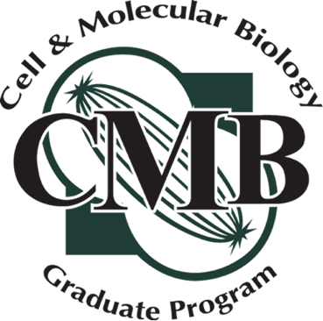
Committee Meeting Guidelines and Expectations

      - Hold committee meetings at least once per year and schedule them well in advance (preferably at least a month). Reserve a room for meetings and arrange zoom links as needed.
      - Review this form before your meeting and be prepared to discuss topics such as timeline for comprehensive exam and dissertation defense.
      - Prepare the committee report, following the instructions contained at the top of the Annual Progress & Committee Report.
      - Return the fully signed Progress & Committee Report to the Dr. Petroff and Alaina Burghardt.

Introductions & Roles (First committee meeting)
Confirm CMB Representative
Confirm process for filling, signing, and returning the Annual Progress & Committee Report to the CMB Program Director.

Discuss CMB Program Requirements
Completed + Planned Coursework
Assess whether curriculum coursework adequately supports research goals
Discuss plans for filling knowledge gaps (eg, through coursework, supplementary reading)
Discuss/reach consensus on timeline for comprehensive exam/dissertation defense

Research Overview
Student presents initial/updated research questions, aims, data, and planned directions
Committee evaluates progress toward expertise in area of study
Committee evaluates progress toward dissertation goals
Committee provides feedback on scope, direction, feasibility, novelty
Clarify expectations for comprehensive exam or dissertation

Additional points for discussion
Identify professional development goals and accomplishments (eg, writing, presentations, conferences)
Identify gaps in technical and professional development and needed/completed training
Discuss goals for fellowship or grant submission
Provide space for the student to raise concerns. This may be done without the adviser in the room.

Expectations & Communication
Agree on frequency of meetings (minimum once per year; more as needed)
Agree upon timeline for comprehensive exam or dissertation defense.

